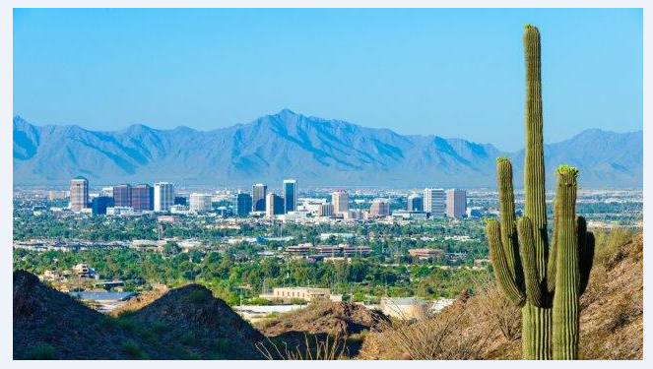

Come Join our Phoenix Maintenance Team

Phoenix needs experienced Maintenance Mechanics (PS-07). If you are interested make sure you update your eReassign information. You may also contact Terry Cook, Manager Maintenance Operations at 602-225-3018 for more specifics.

What does Phoenix have to offer you ask?
- Phoenix is the United States’ sixth-largest city with a population of over 1.4 million.
- Greater Phoenix (which includes, among others, the cities of Chandler, Glendale, Scottsdale and Tempe) has a population of nearly 4.3 million and covers 2,000 square miles.
- Phoenix's elevation is 1,117 feet.
- Greater Phoenix is located in the Sonoran Desert, which is one of the wettest and greenest deserts in North America, thanks to 3-15 inches of annual rainfall.
- According to data compiled by the National Climatic Data Center, Phoenix basks in sunshine more often than any other major metropolitan area in the U.S. The sun shines on Phoenix during 85 percent of its daylight hours.
- Phoenix has an average annual rainfall of 8.04 inches, an average temperature of 75.05 degrees and an annual high temperature of 86.7 degrees. The average high temperature in winter is 67 degrees.
- Greater Phoenix is home to more than 200 golf courses.
- Phoenix is one of the few U.S. cities with franchises in all four major professional sports leagues: Phoenix Suns (NBA), Arizona Diamondbacks (MLB), Arizona Cardinals (NFL) and Arizona Coyotes (NHL).
- 15 Major League Baseball teams conduct spring training in the Cactus League.
- The University of Phoenix Stadium will be the host of the 2017 NCAA Men’s Basketball Final Four.
- Phoenix International Raceway plays host to two NASCAR events each racing season.
- Phoenix is home to the largest municipal park in North America. South Mountain Park and Preserve covers more than 16,500 acres and has more than 50 miles of hiking, biking and equestrian trails.
- There are six lakes within a 75-minute drive of Phoenix.

